# **Delegation Event Model**

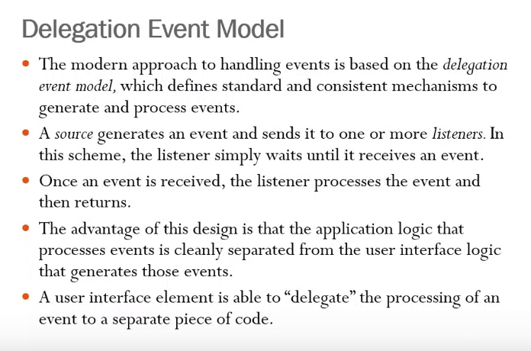

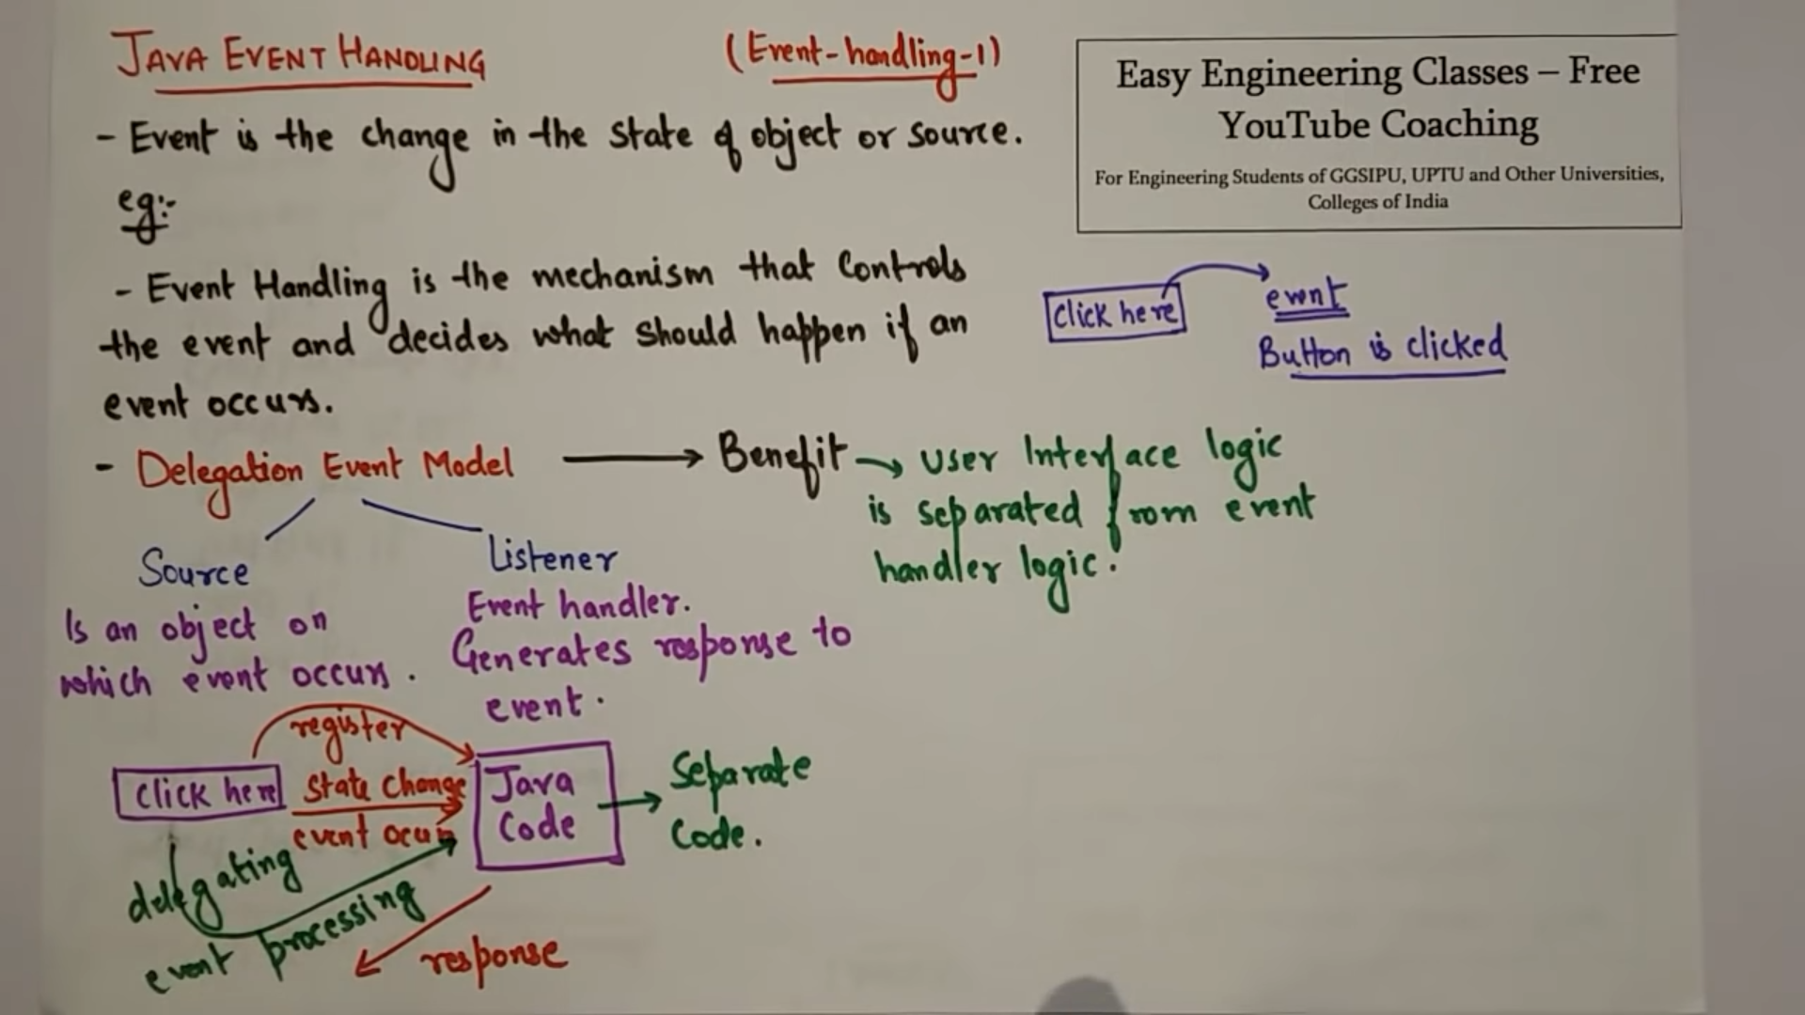

1. There can be one listener.
2. There can be a receiver who receives and sends it to another listener.

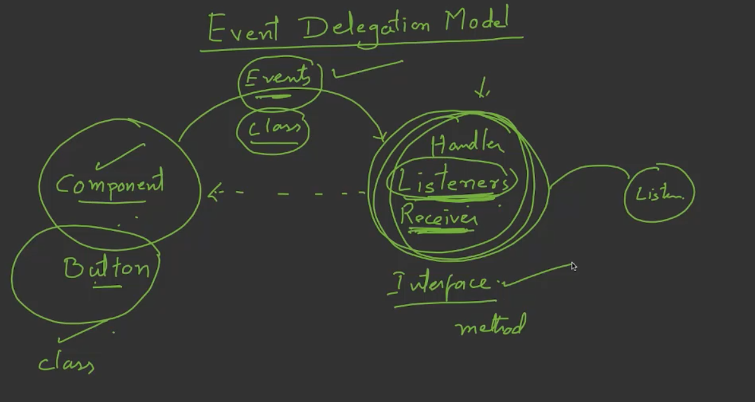

Classes are built in-available for components.  
Classes are built in-available for events.  
Listener will be our own user_defined class which implements some interface.

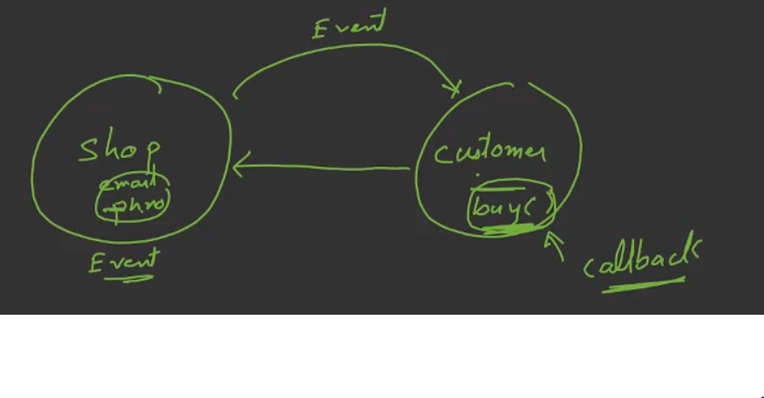

You have given your mobile number and email_id to the shop.  
After some-times the shop announces the offer and sent to the customer via sms,email. (event is generated).   
These offers can be claimed by the customer (event-handling)

**Outline of even classes and listener interface**

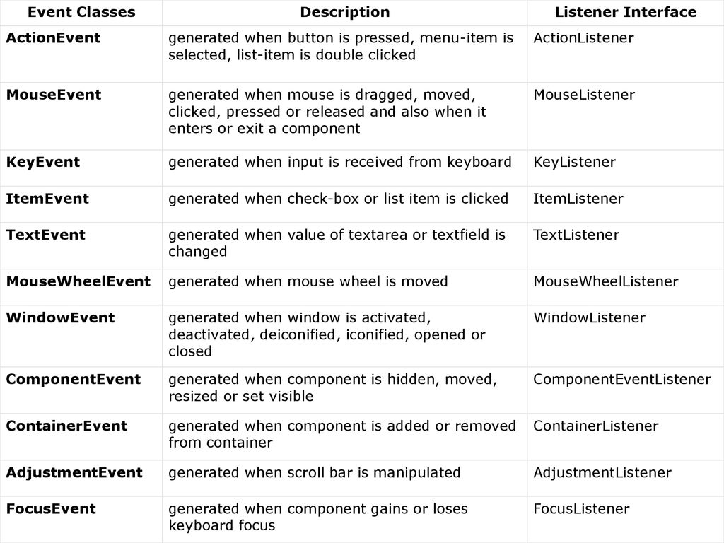

# **Event**

Event Source 🡪 an object that generates an event. When-ever an event is generated, source must provide the occurred event info to the listener by registering the control with the corresponding listener.

Object.addTypeListener(this);  
public void addTypeListener (TypeListener this) { }

Event Listener 🡪

Implementing the ActionListener interface  
public void actionPerformance (ActionEvent ac) { }

Event classes 🡪

# **Event Sources**

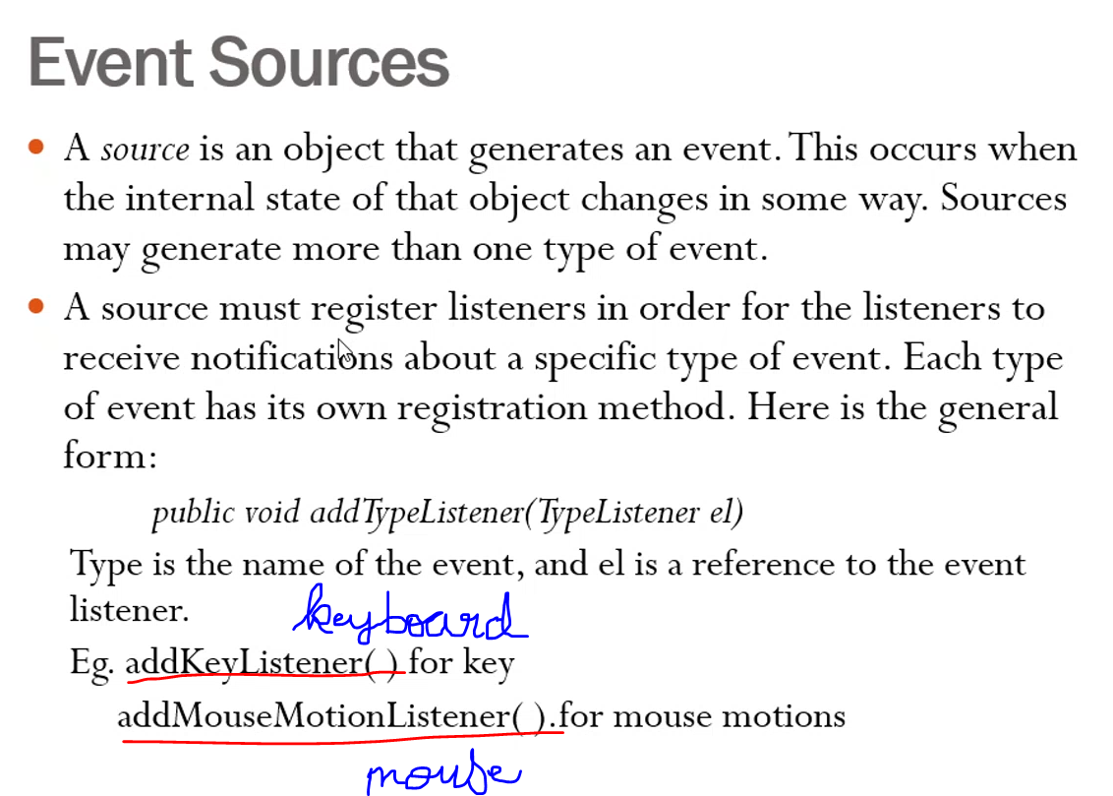

A mouse is an object that generates an event. Mouse can generate events like scroll, click, double click etc..

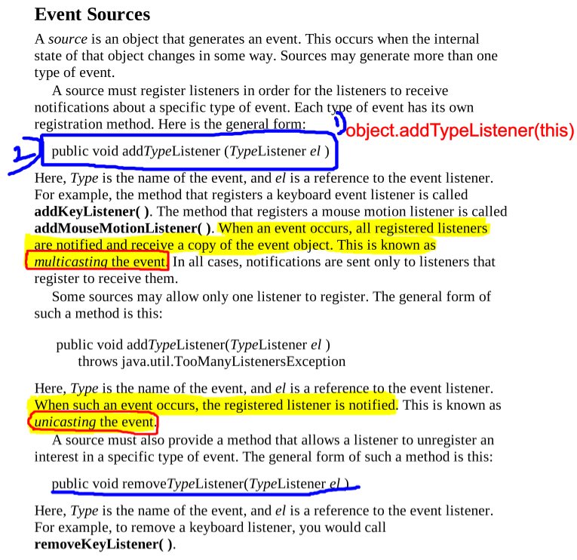  
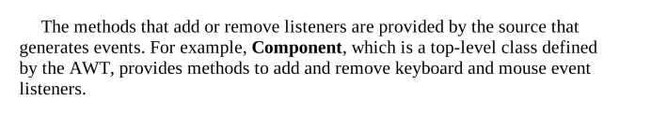

# **Event Listeners**

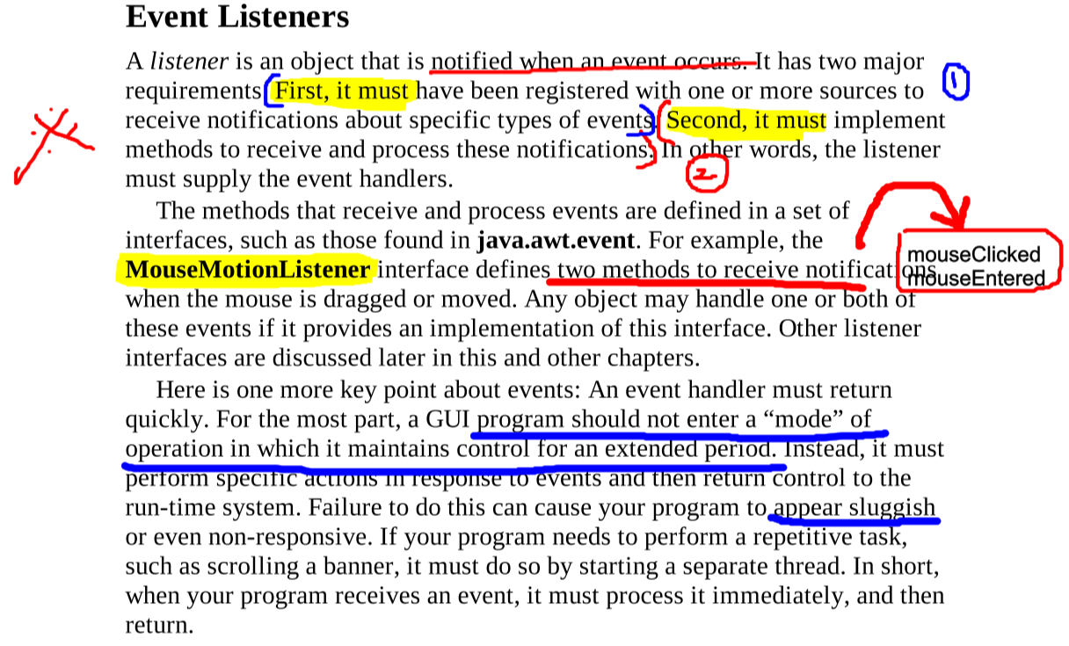

# **Event Classes**

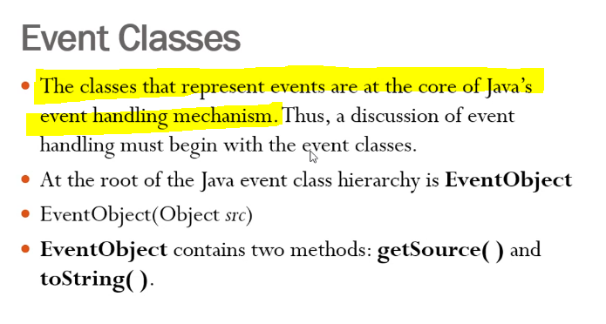

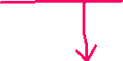

Returns the string equivalent of an event Returns the source of the event

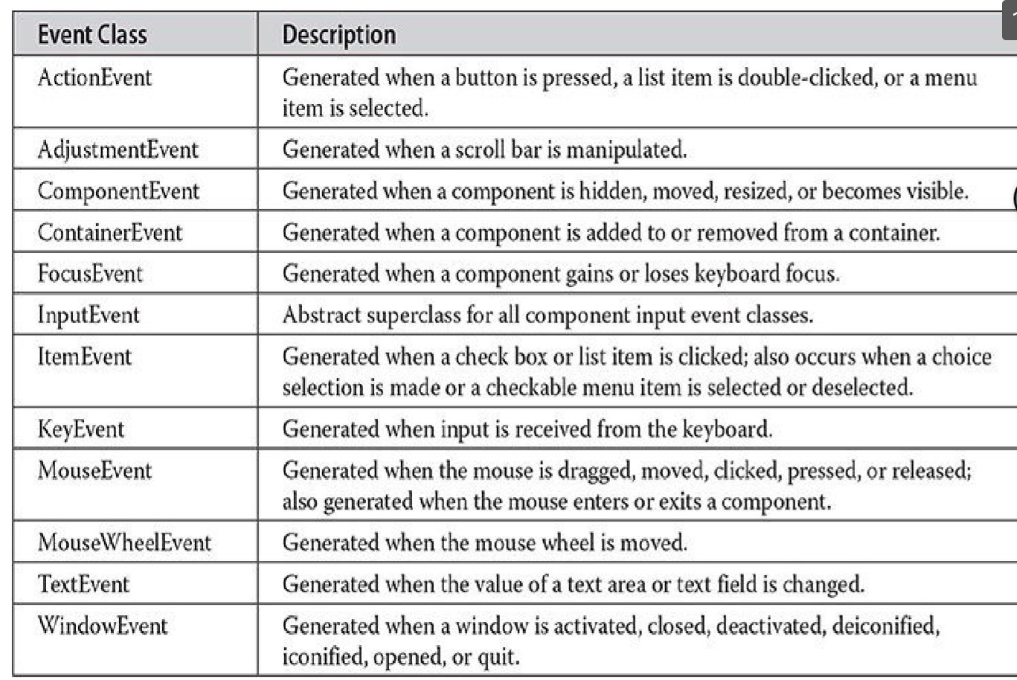

## ActionEvent Class (button press)

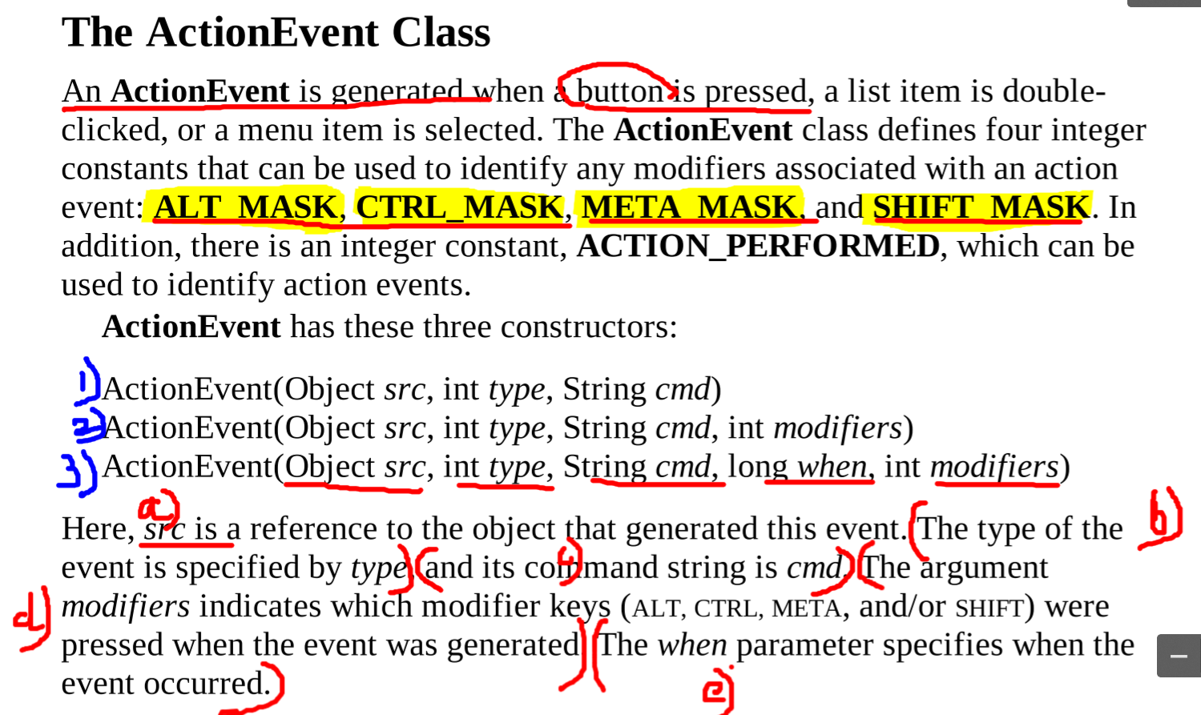

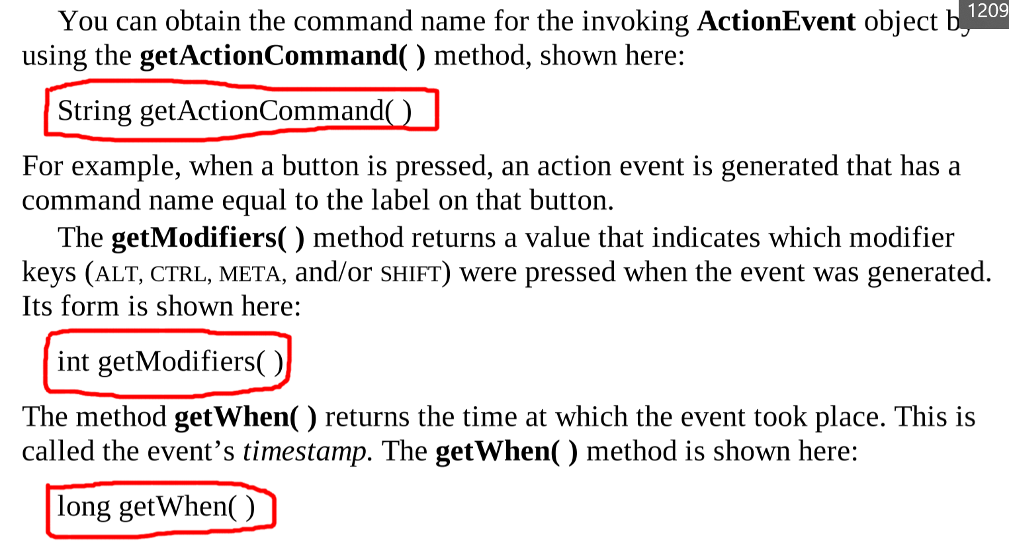

## Adjustment Event Class (scroll bar)

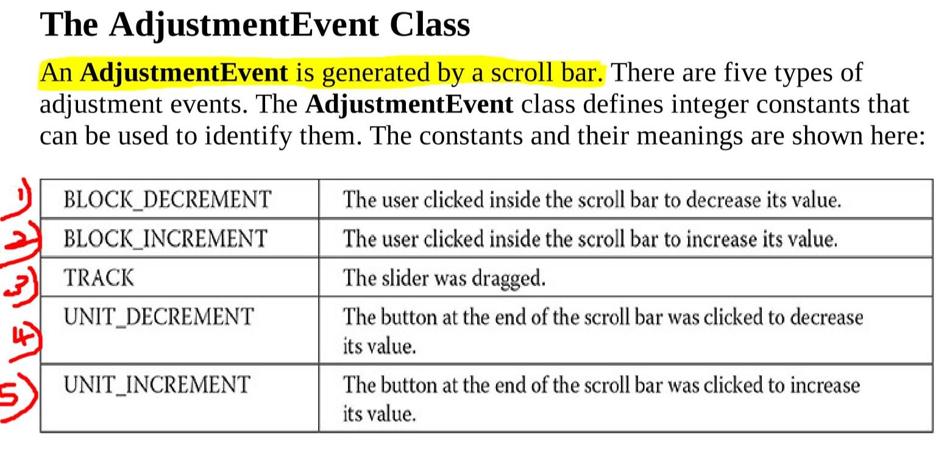  
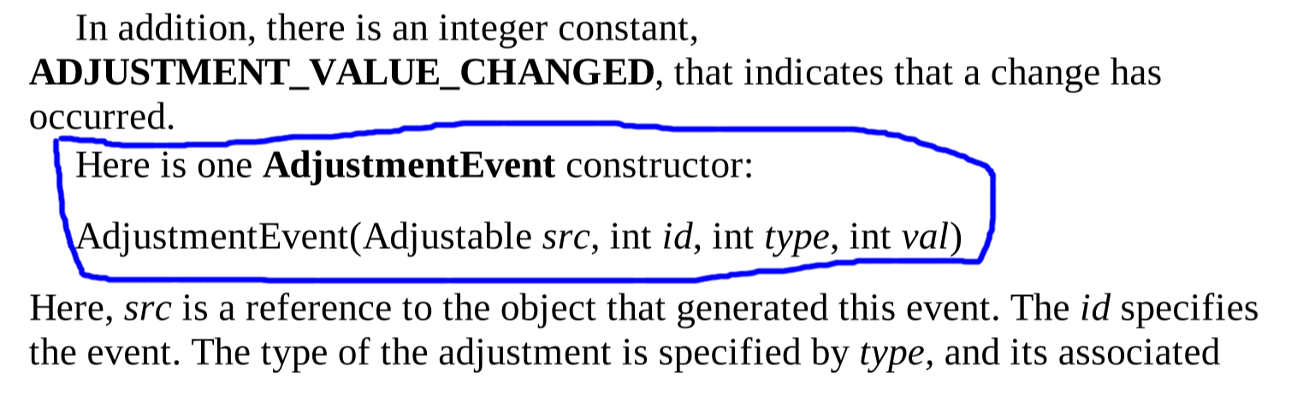

## Component Event Class (size, position, visibility of a component changed)

The component may be a label, textbox, combo-box, picture   
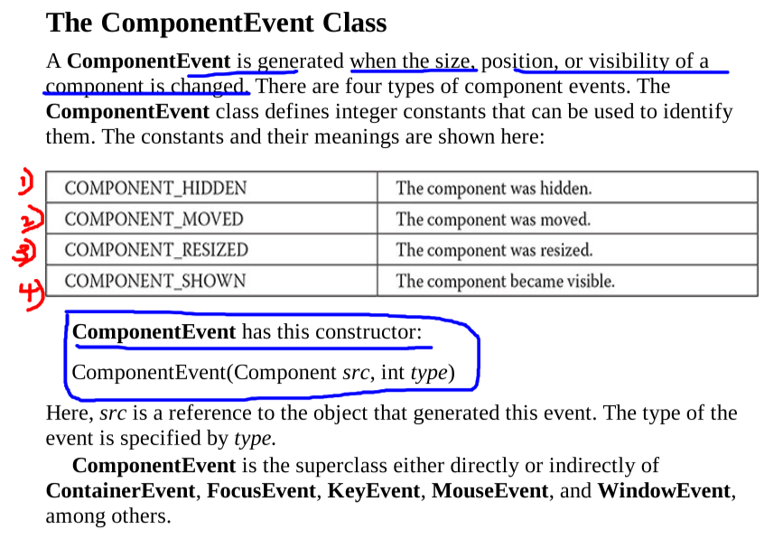  
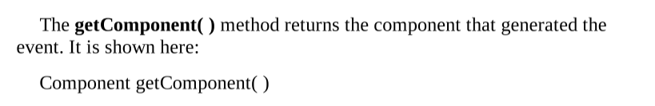

## Container Event Class

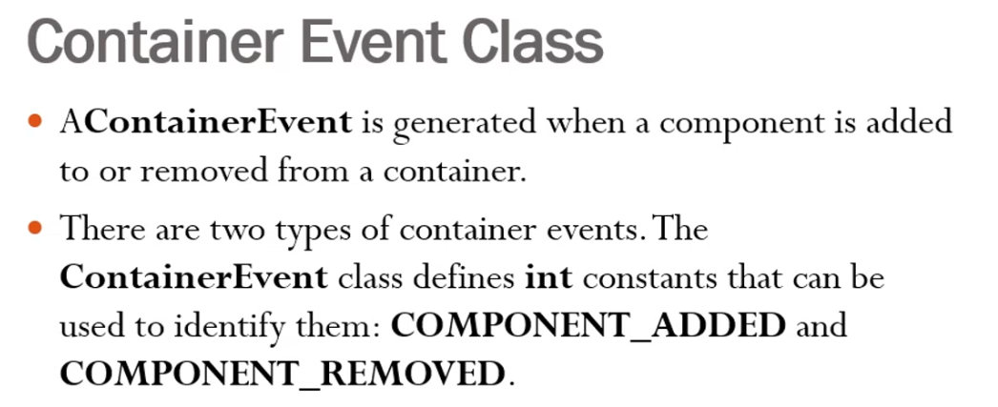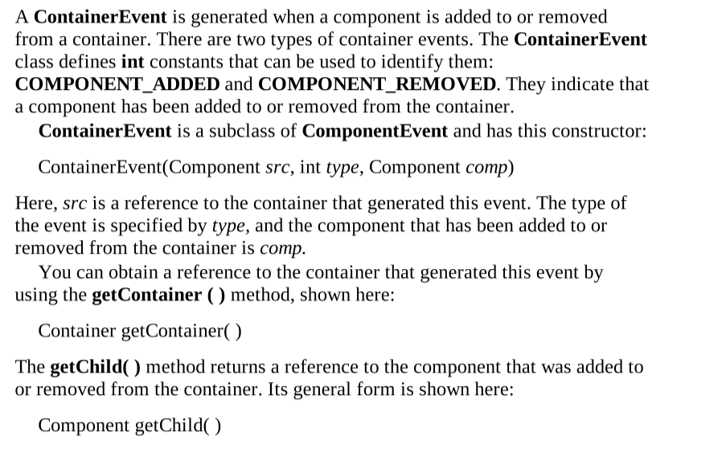

## **Focus Event Class**

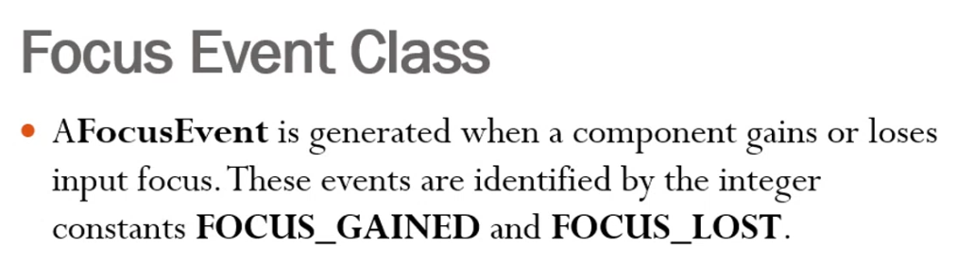

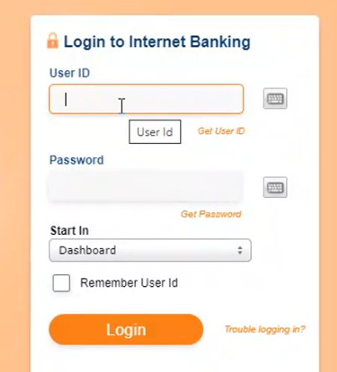 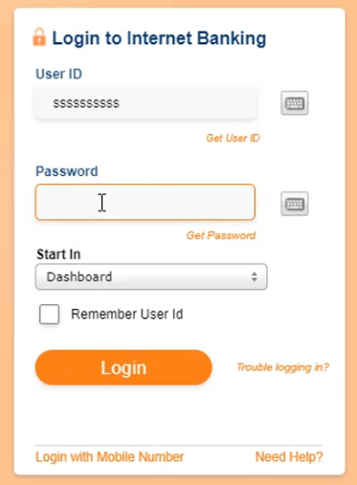

User-id is focussed and User-id is not focussed and  
Password is not focussed Password is focussed

# Key Event Class

## **Mouse Event Class**

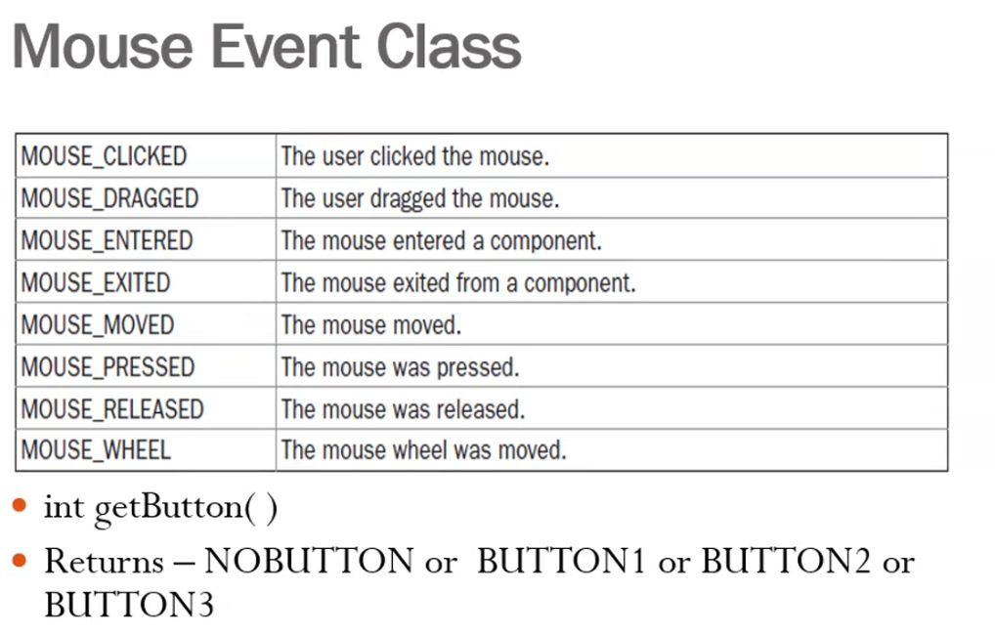

## **Mouse wheel Event Class**

## **TextEvent Class**

## **Window Event Class**

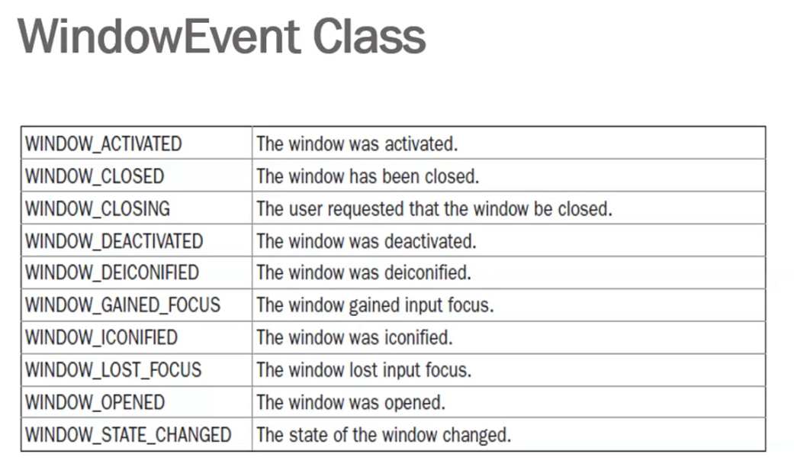

# **Source of Events**

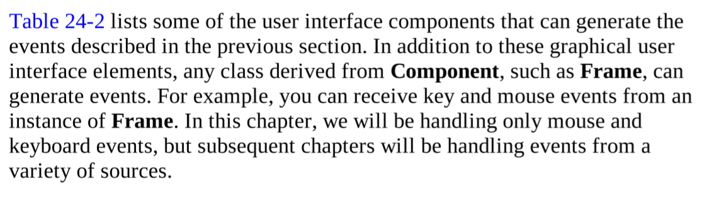  
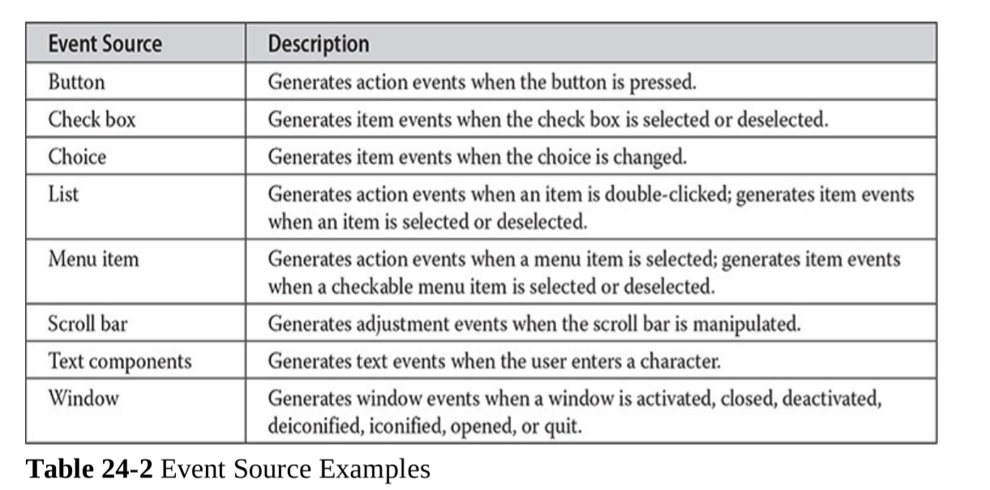

The above events are generated and these must be handled by the listeners

# **Event Listener Interface**

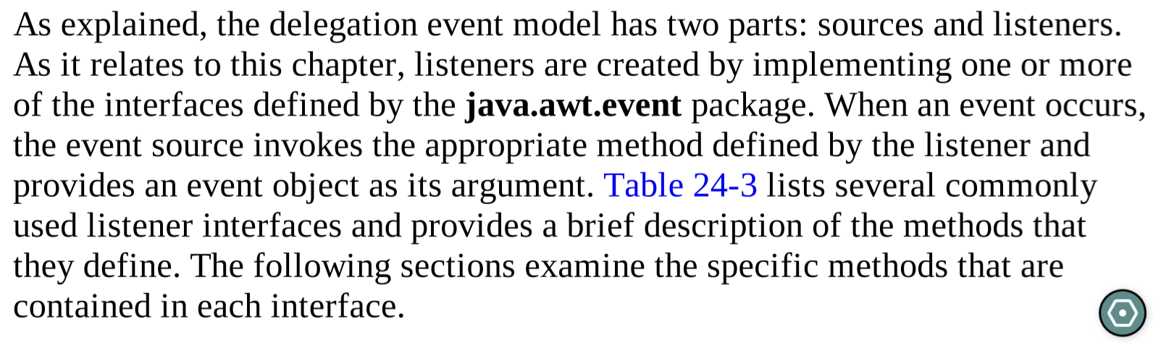

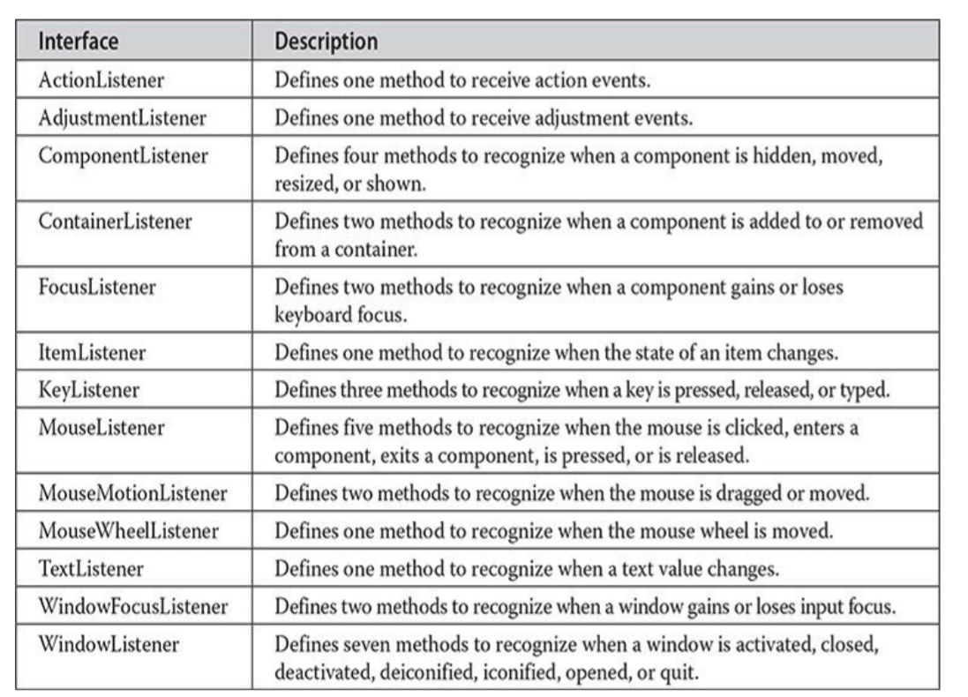

## **ActionListener Interface**

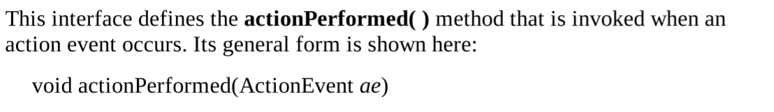

## **Adjustment Listener Interface**

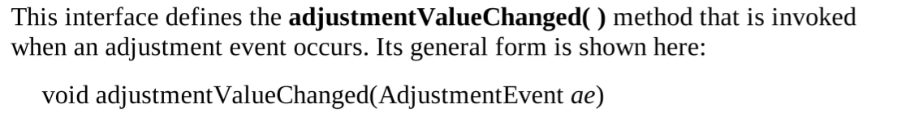

## **Component Listener interface**

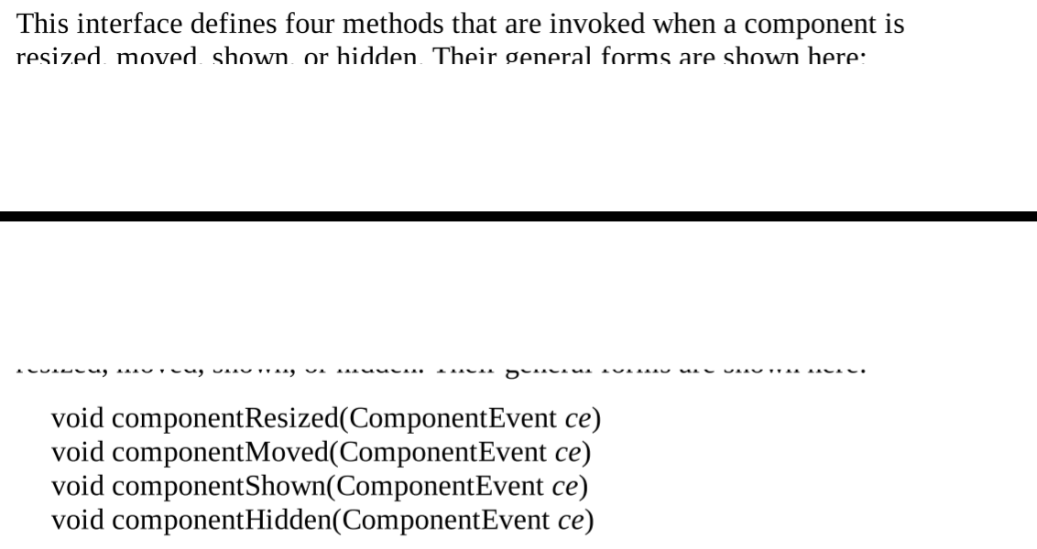

## **Container Listener interface**

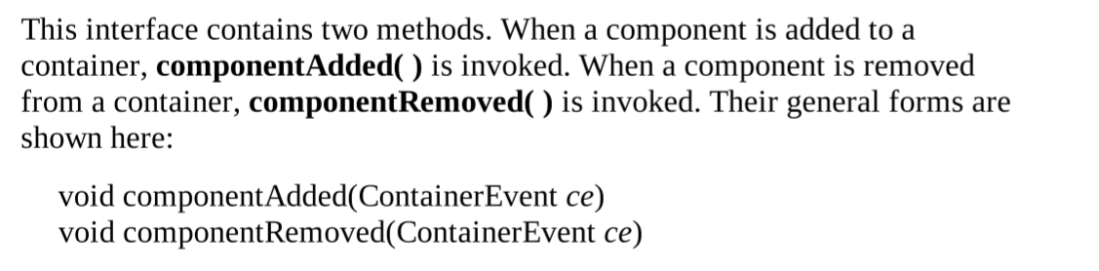

## **Focus Listener interface**

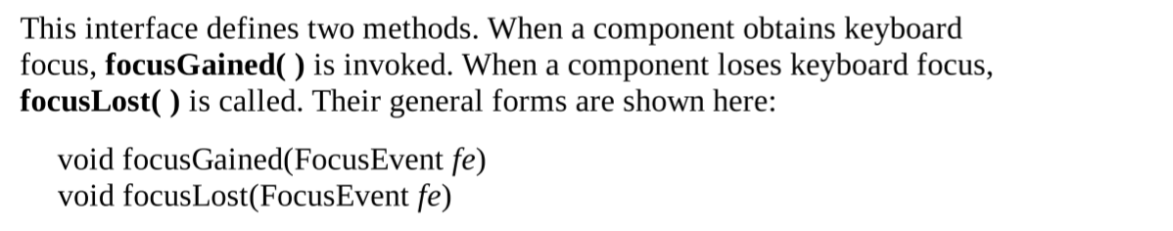

# Key Listener Class

## **Key Listener interface**

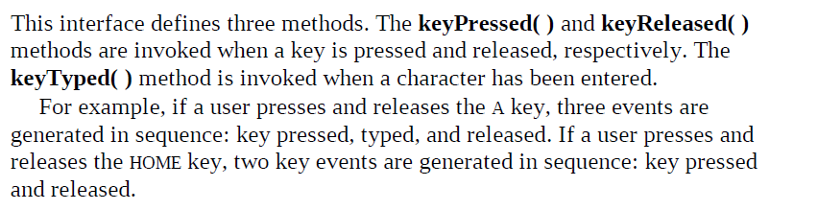  
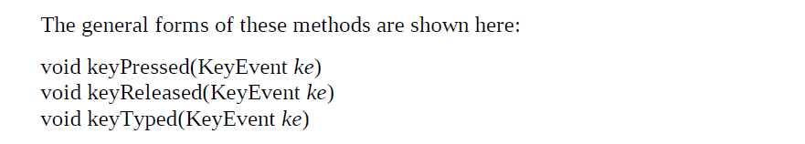

## **Mouse Listener interface**

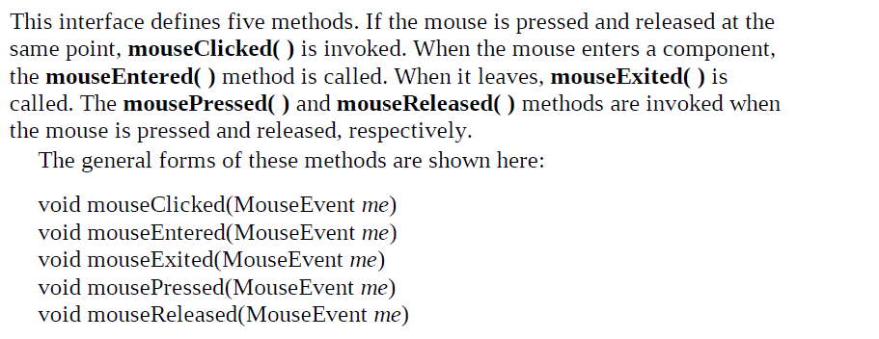

## **Mouse Motion Listener interface**

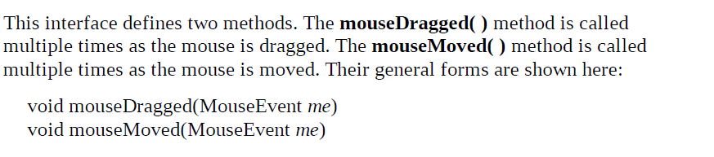

## **Mouse Wheel Listener interface**

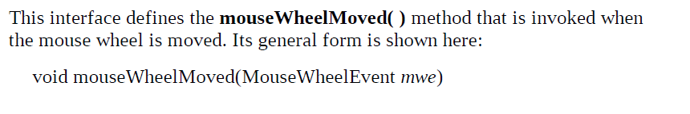

## **Window Focus Listener interface**

## **Window Listener interface**

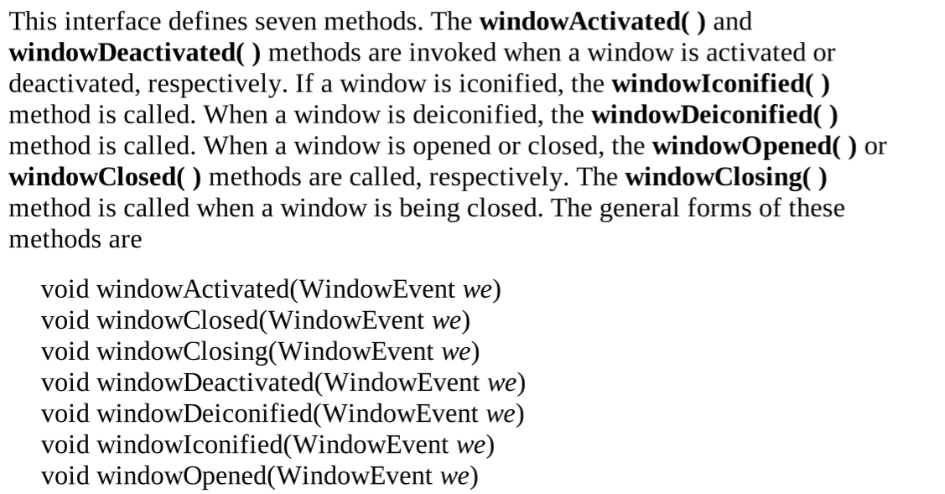

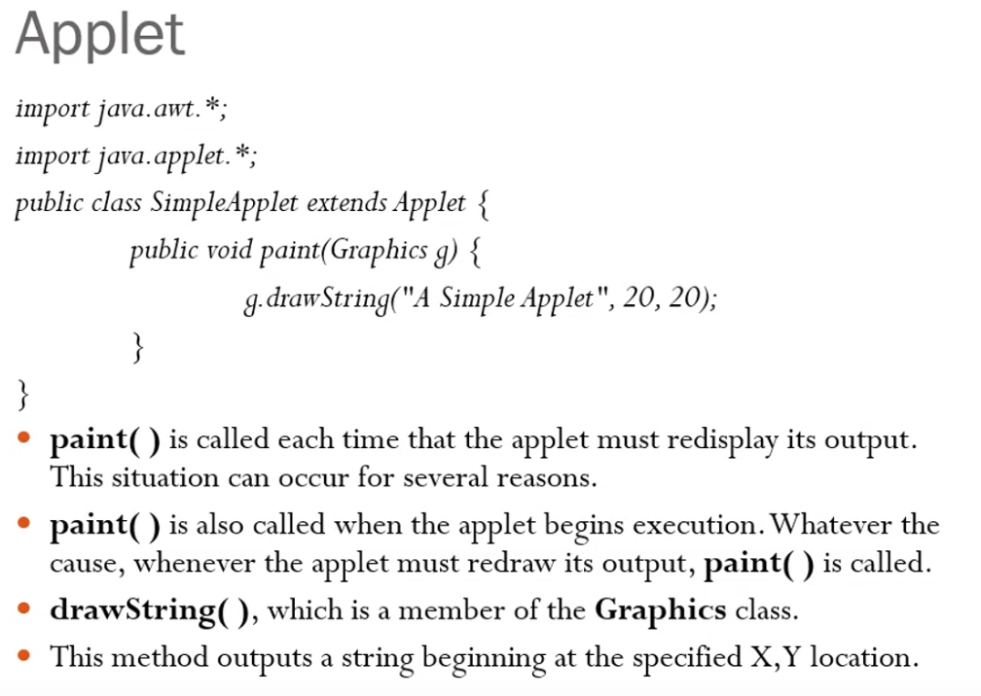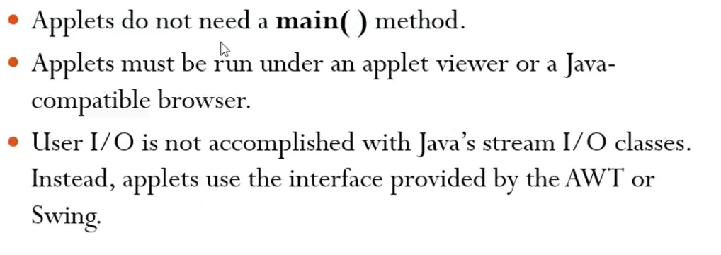

**Painting is the process of changing the window**

**java-applet is running at the back-end completely. Unless the applet window is closed, it runs.**

**Refer button_ActionListner.java**

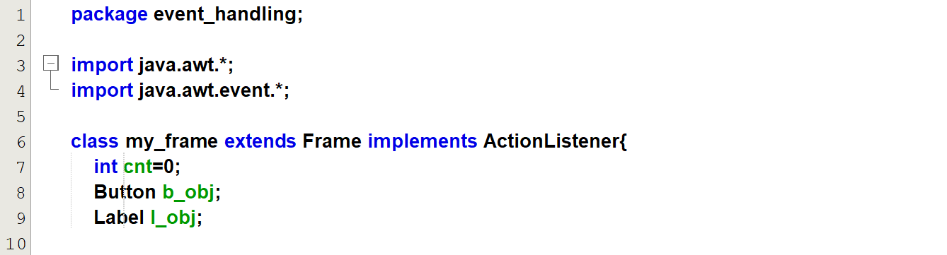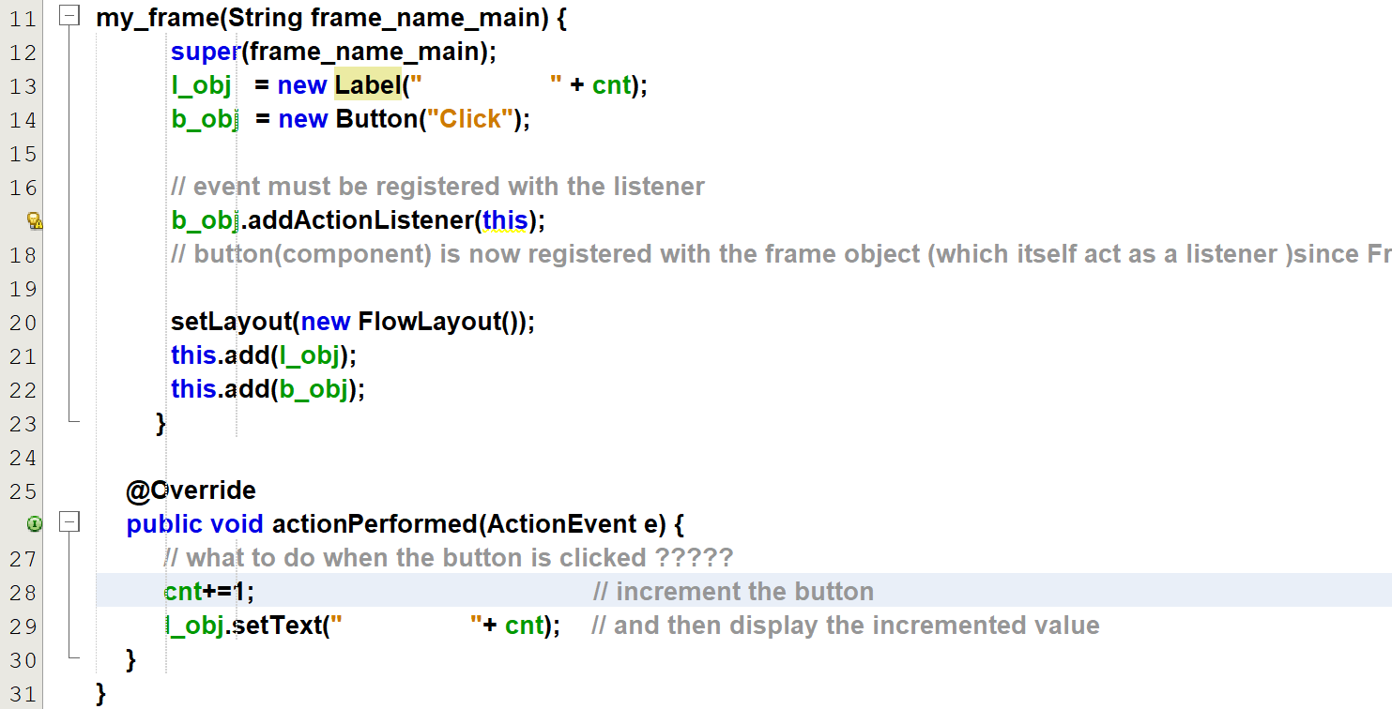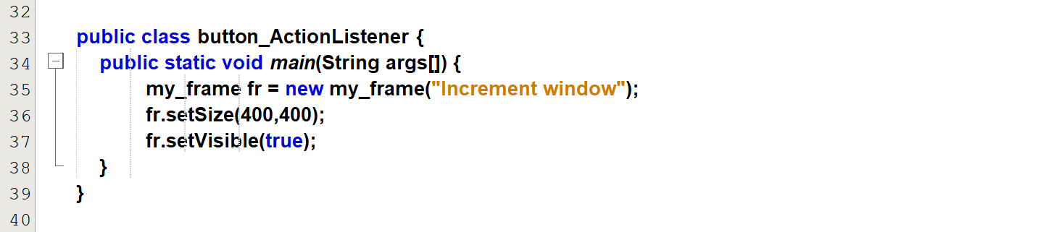

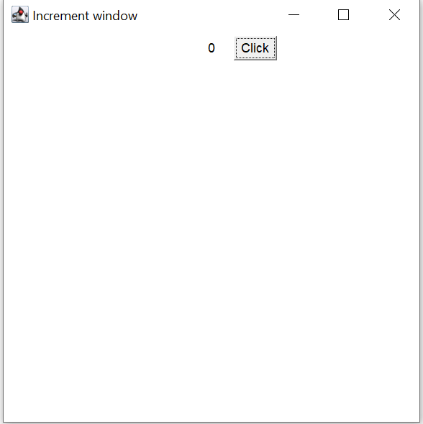

After clicking 6 times

